# Creating and Refreshing a Materialized View - Updated

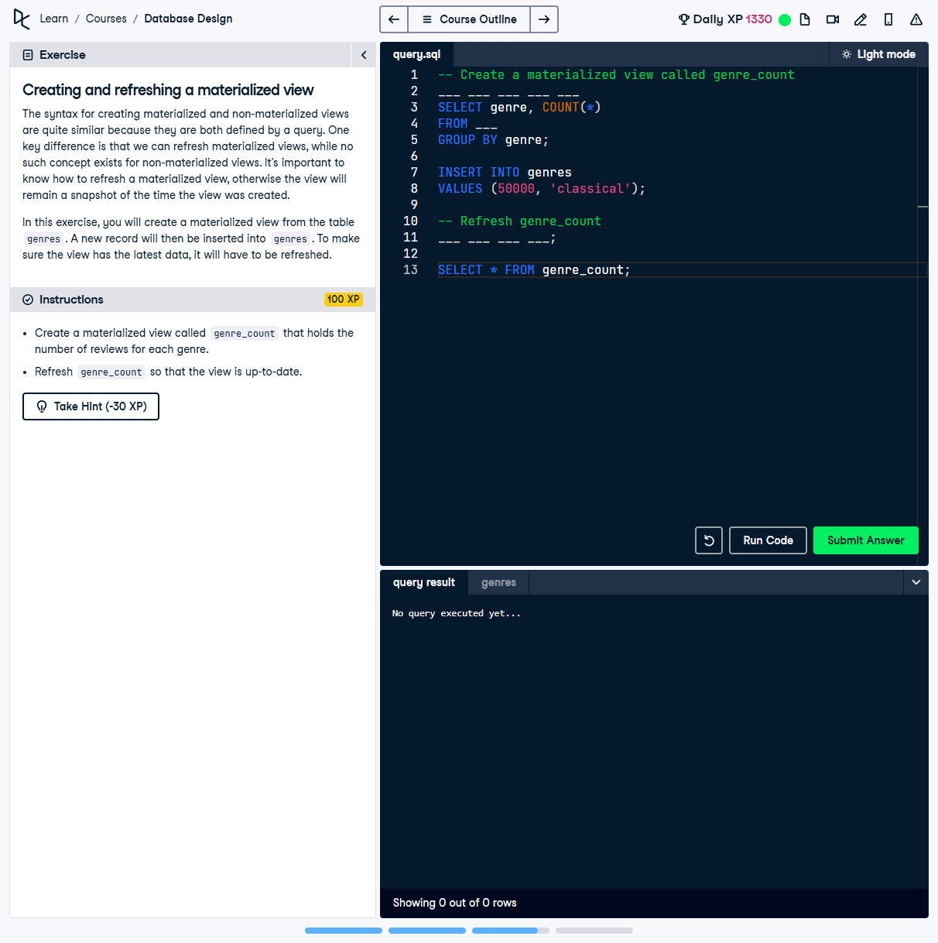

## Question:

Create a materialized view called `genre_count` that holds the number of reviews for each genre. After inserting a new record into `genres`, refresh `genre_count` so that the view is up-to-date.

## Full Answer (SQL Code):

-- Create a materialized view called genre_count  
CREATE MATERIALIZED VIEW genre_count AS  
SELECT genre, COUNT(*)  
FROM genres  
GROUP BY genre;  
  
-- Insert a new record into genres  
INSERT INTO genres VALUES (50000, 'classical');  
  
-- Refresh the materialized view to update its data  
REFRESH MATERIALIZED VIEW genre_count;  
  
-- Output the refreshed view  
SELECT * FROM genre_count;

## Explanation of the Answer:

The `CREATE MATERIALIZED VIEW` statement generates a snapshot of aggregated review counts for each genre. A new record is then inserted into `genres`. Since materialized views do not auto-refresh, the `REFRESH MATERIALIZED VIEW genre_count;` command is executed to ensure the view has the latest data. Based on the hint, the column alias `AS review_count` is not necessary, so it has been omitted.